
FIELD INVESTIGATION REPORT RESIDENCE AND BUSINESS/OFFICE
APPLICATION NO |  |  |  |  | APPL00722490
State | Tamil Nadu |  | Branch |  | Edappadi | Product |  | MSME
FI Initiated Date |  | 25-09-2026 Time 00:00 |  |  | FI Upload Date |  | 28-09-2026 Time 00:00
Applicant/Co-Applicant/Guarantor Details |  |  |  |  | Applicant
Name Of the Applicant/ Co-applicant/Guarantor |  |  |  |  | Sri Kanth Arjunan
Residence Address |  |  |  |  | 258-1 devalanthandaa colony komarayanur, po , Erode, Tamil Nadu, 638504
Mobile No |  |  |  |  | 9345684851
Own House or Rented House |  |  |  |  | Own
No. of the years in the Residence (If less then 6 months, please write last Residence address) |  |  |  |  | SINCE BIRTH
Traceability of house (Easy /Difficult/Unable to Locate) |  |  |  |  | Easy
Nature of Business of Applicant/Co applicant/Guarantor |  |  |  |  | PVC PIPE SALES (MANAGER)
Name of Employer (If salaried) |  |  |  |  | PVC PIPE SALES (MANAGER)
Office Address |  |  |  |  | 1 , Kumarapalayam Main Road , kalleripatti ,Thiruchengode 637211, 637211
Total Work experience/Total Business vintage (in years) |  |  |  |  | 06 MONTHS
No of Years with present Employer/ Business |  |  |  |  | 06 MONTHS
Overall Observations on Life Style of Applicant/Co-applicant/Guarantor |  |  |  |  | Medium
Neighbor Feedback at Residence (Minimum 2-person Name) |  |  |  |  | Sarkuru and Lakshimi
Neighbor Feedback at Business address (Minimum 2-person name) |  |  |  |  | Karthik and kanaga
Residence Visit Remark
Residence visits remarks: The given residence address was visited. At the time of the visit, the door was found locked. We verified the details with two neighbours, Mr. Surkuru and Mrs. Lakshmi, who both confirmed that the address provided is the applicant's own house. The applicant Mr.Sri Kanth Arjunan has been residing at this address since birth. The family consists of three members: the applicant, his father and his mother. The applicant works outside the city and visits home about once a month, while only his parents stay at the residence on a regular basis. Status: Positive.

Residence’s Neighbors Feedback Remarks
Residence Neighbors Feedback Remarks: During the residence visit, we met the neighbors, Mr. Sarkuru, who resides in the house behind the applicant's residence, and Mrs Lakshimi, who resides in the first house behind the applicant's residence. The neighbors confirmed that the applicant, Mr. Sri kanth, has been residing at the given address, the residence was own house since birth. They further stated that the family consists of 03 members. Overall, the residence verification status is Positive.

Residence Status |  |  |  | POSITIVE
Business/Office Visit Remarks
Business visit Remarks: We visited the business premises met the applicant, Mr. Sri Kanth. During the visit, we observed that the applicant is engaged in the pvc pipe manufacturing company and has been working as a manager for the past 06 months and getting income of Rs. 20,000. During our visit, around 2 staff members were present at the premises. However, based on the neighbour’s confirmation regarding the applicant’s occupation, the office address verification status was concluded as positive.
Business/Office Neighbors Feedback Remark
Business Neighbors Feedback Remarks: During the residence visit, we met the neighbors, Mr.Karthik, who is co-worker and Mrs. Kanaga Both neighbors confirmed that the applicant, Mr. Sri Kamth, has been working at the given address, for past 06 months. overall, the business verification status is Positive.

Business/Office Status |  |  |  | POSITIVE
Photograph of Applicant/Co-Applicant/ Guarantor Residence to be affixed.
Required all visit Photo with GEO Tagging + Selfi with Customer/GTR + house front side
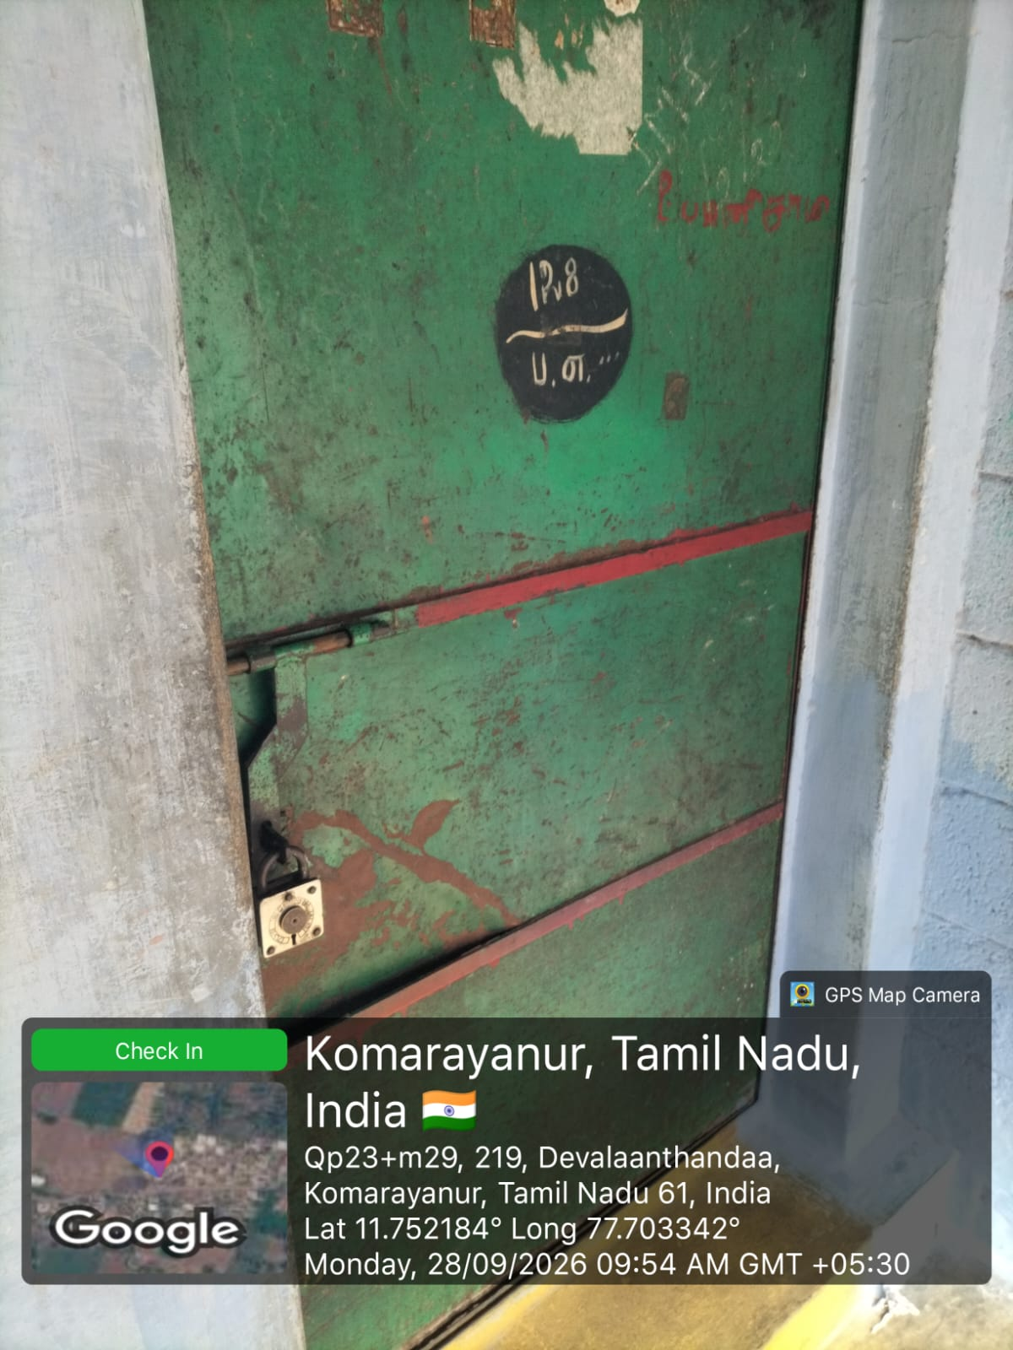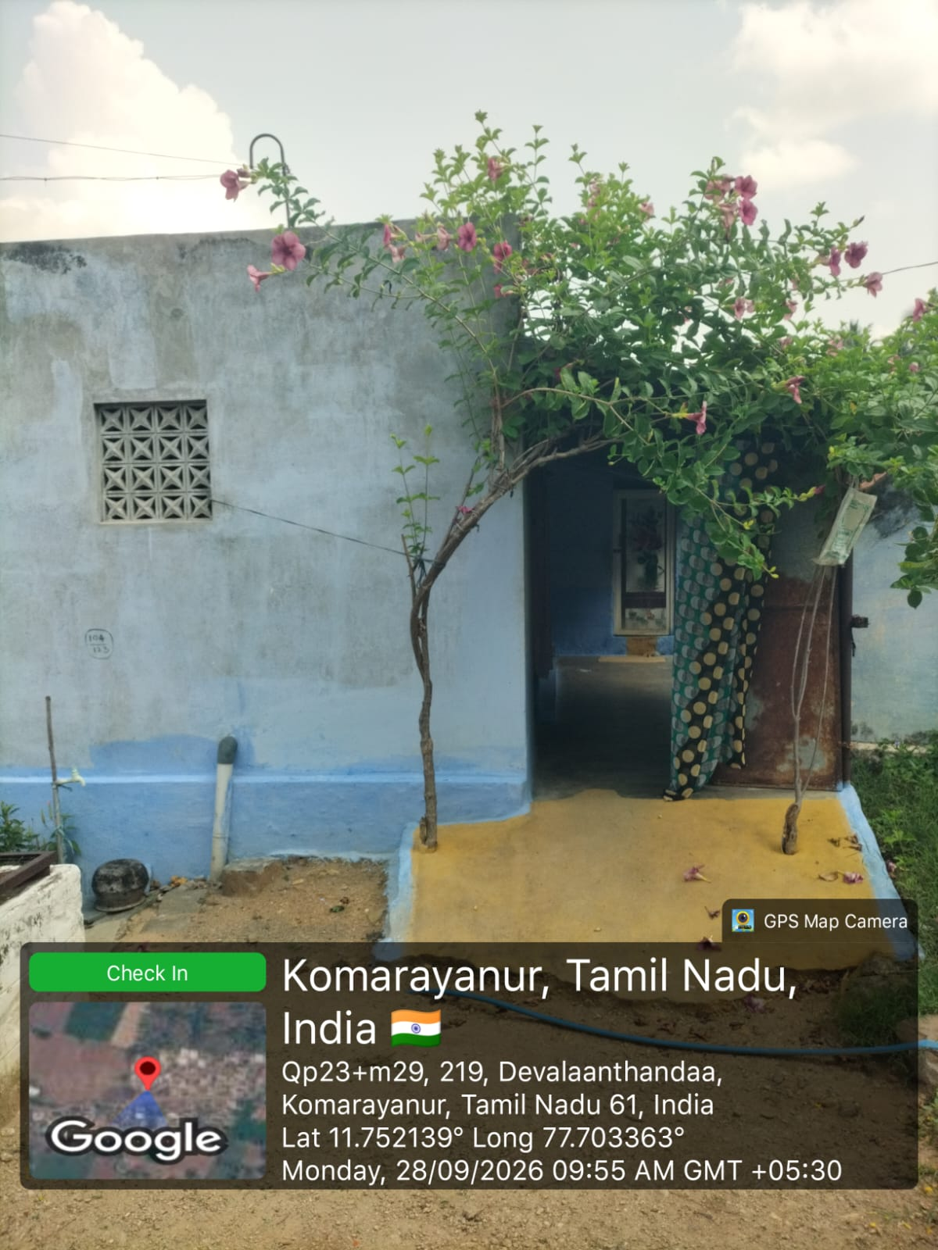

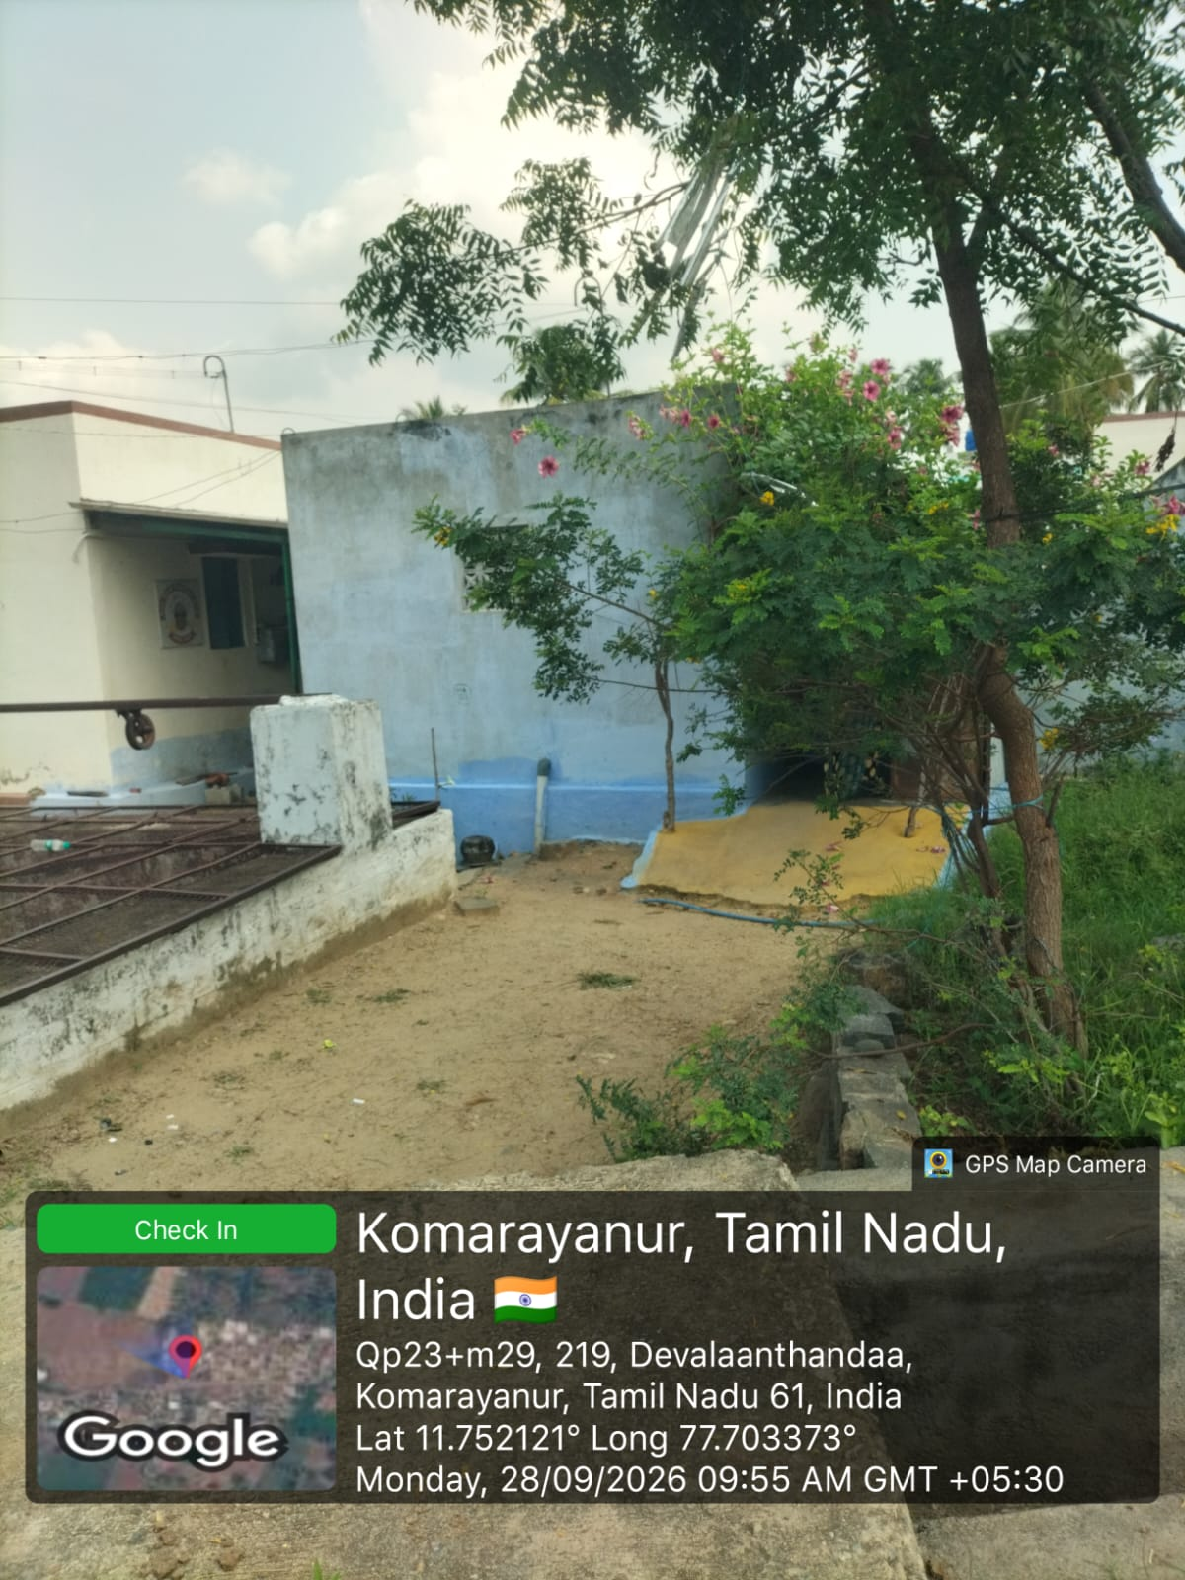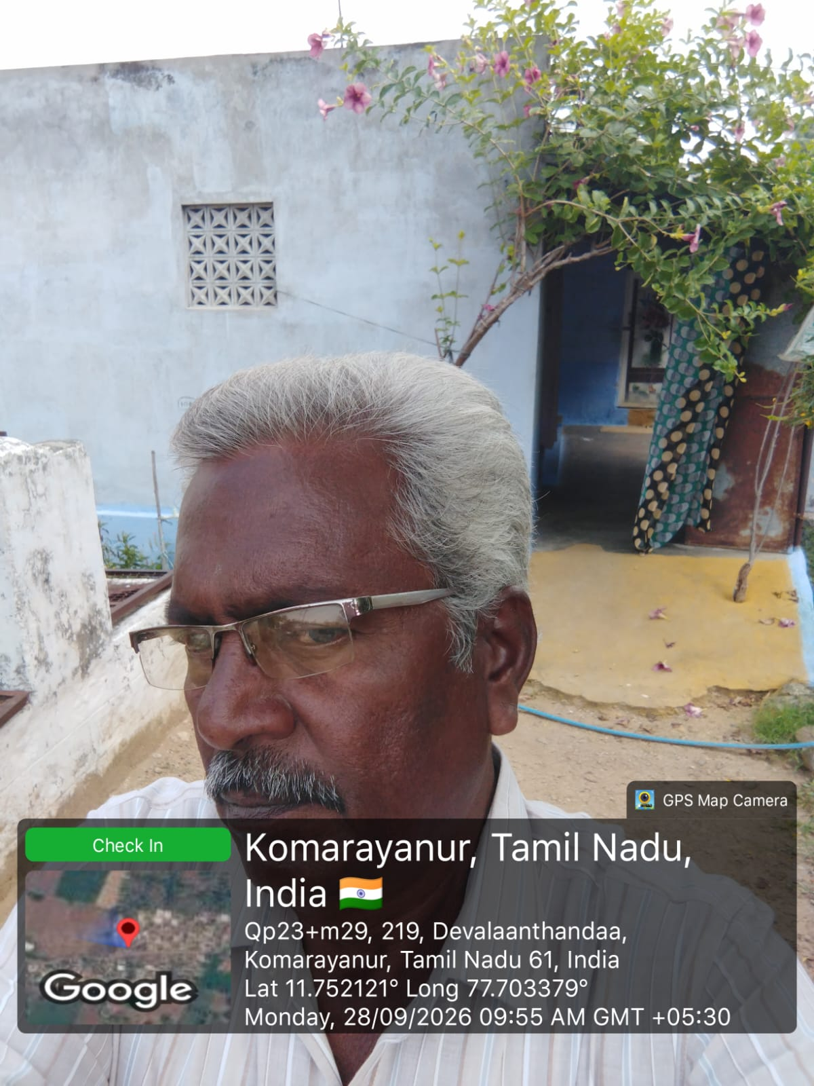

Photograph Of Applicant/Co-Applicant/ Guarantor Office to be affixed.
Required Photo attached with GEO Tagging + Salfi with Customer+ Business setup + Livestock + Business Proofs + Signe Board
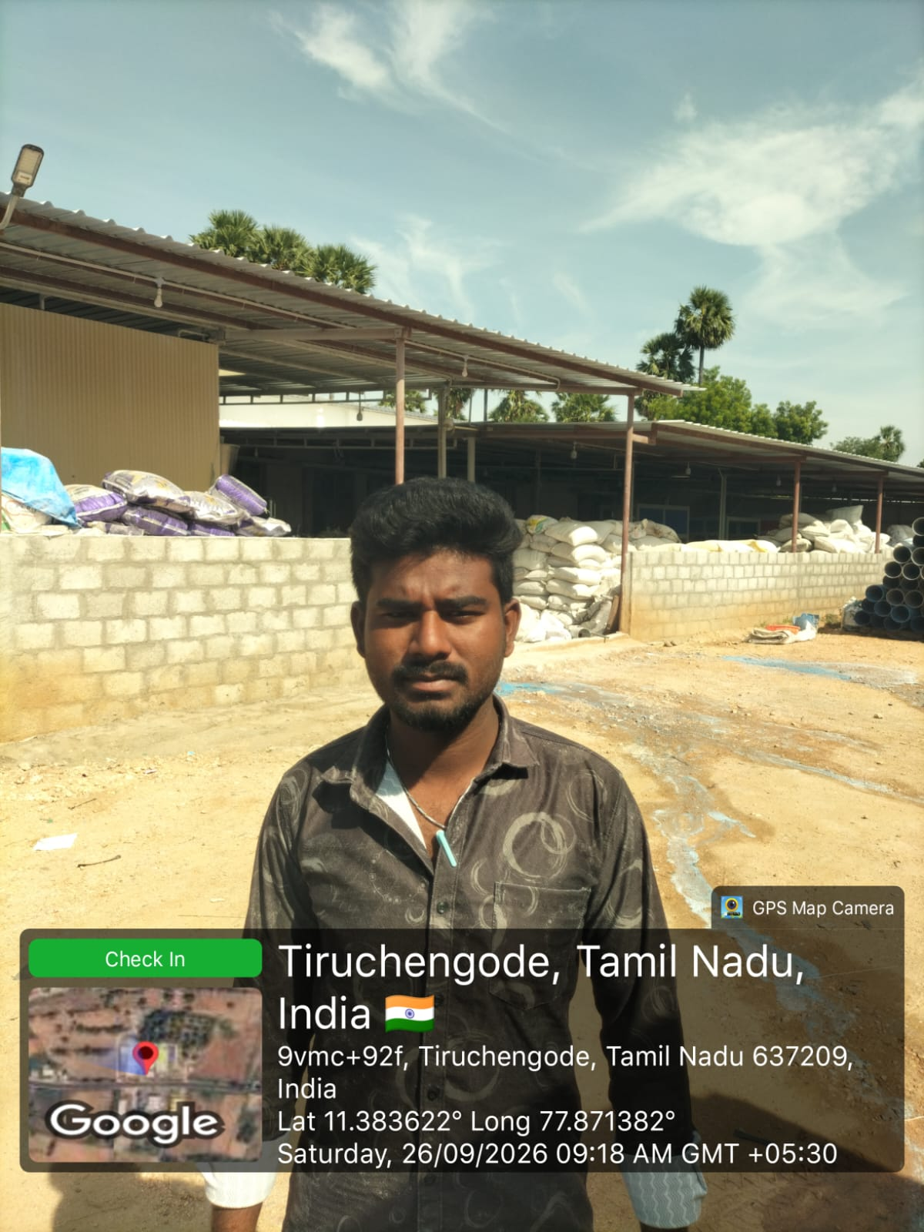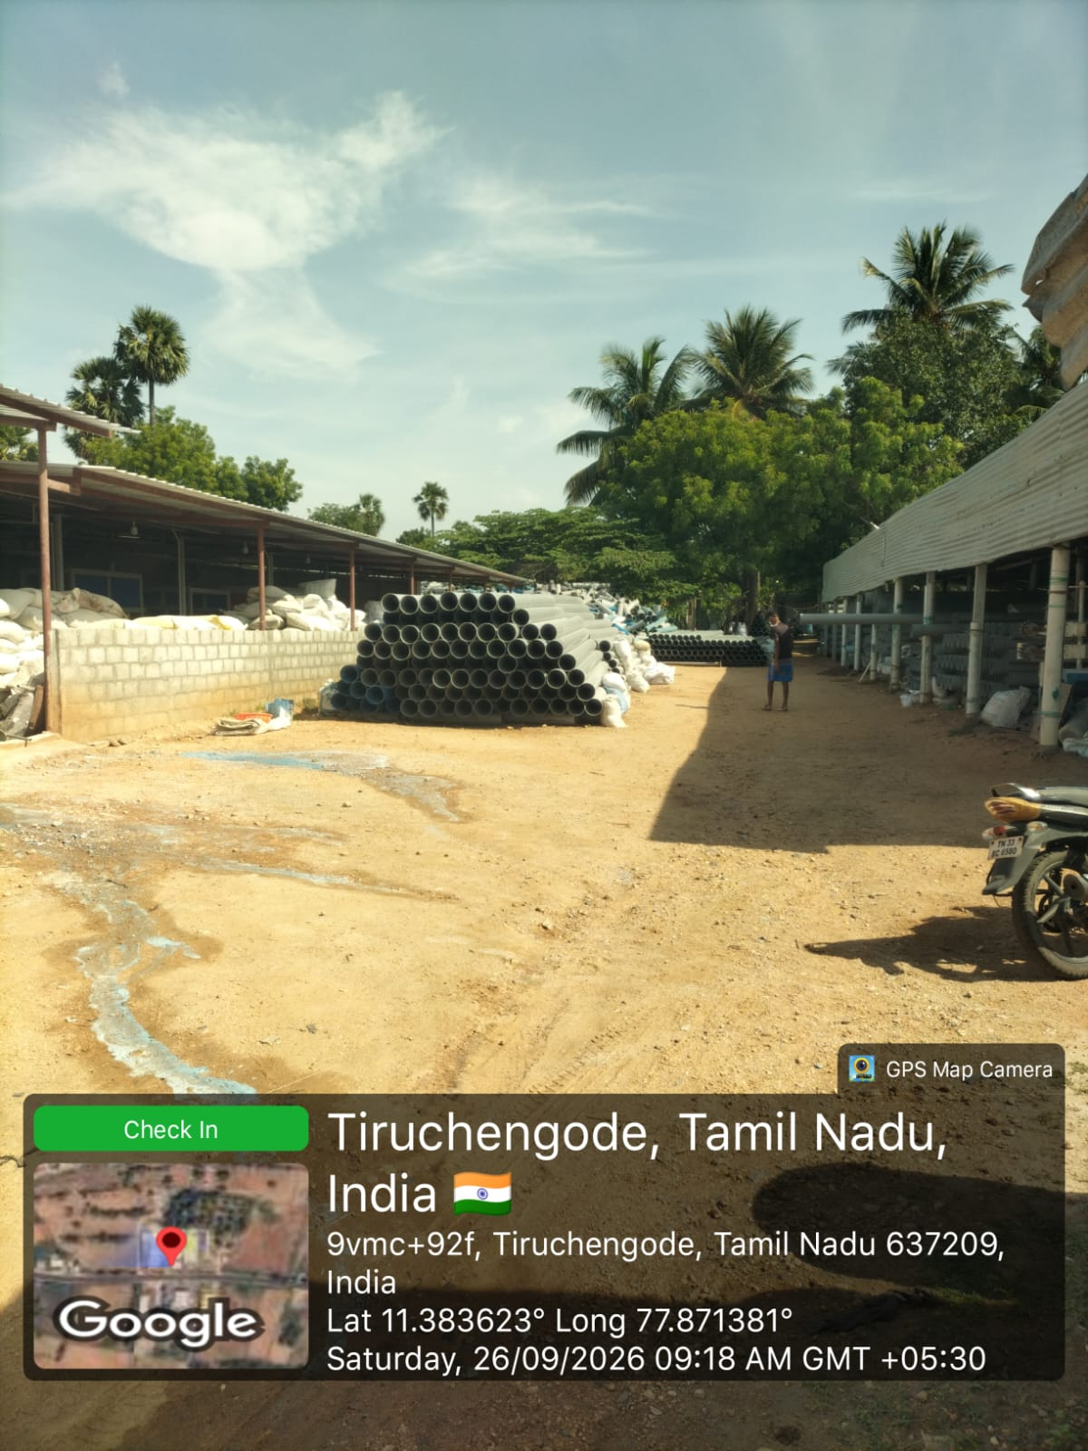

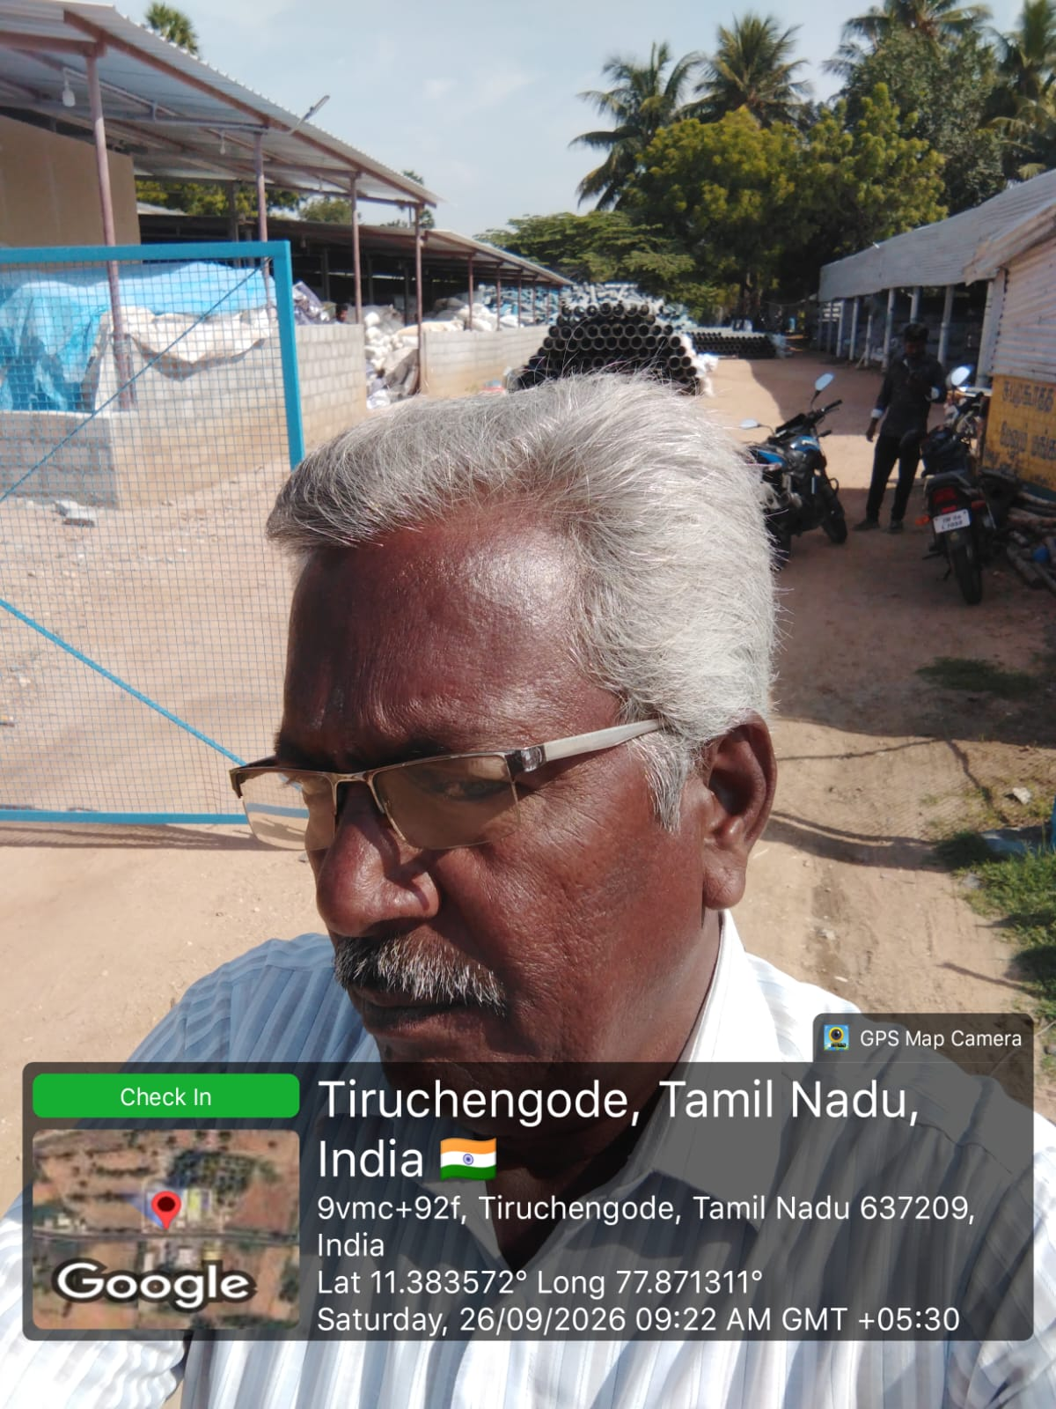
Criminal/Political (Negative) Feedback as per Neighbors
Criminal Record (Illegal activities Titel Name) |  |  |  | No
Any Negative Indicators Found (Example: Affiliation with Political/Community Dominated Area/Religion Parties, Police, Advocate/Repo Agent/Acting Profession Etc.) |  |  |  | No
FI Inspected By |  |  |  | PRAKASH
Agency Seal and Signature


